**TWITTER SCRAPING USING SNSCRAPE STREAMLIT**

Scraping of Data's from Twitter with mongodb, streamlit using Snscrape.

**Overview of the Twitter Scraping:**

Created GUI using Streamlit

* Create any keyword or hashtag to be searched
* Enter an option keyword Eg: "elon musk"
* Select a start and end date
* Number of tweet to be scraped
* Scrape data using TwitterSearchScraper and TwitterHashtagScraper.

After Scraping the data from twitter:

* Upload collections in database shown
* Download CSV and JSON
* Database collection uploaded to MongoDB
* Displayed all tweets

**LIBRARIES AND PACKAGES TO BE INSTALLED AND IMPORTED:**

* Snscrape: import snscrape.modules.twitter as sntwitter
* Pandas: import pandas as pd
* Pymongo: import Pymongo
* Datetime: import Datetime
* Streamlit: import streamlit as st

**Roadmap How it works:**

* I collected keyword, start date, end date, number of tweets from the user using Streamlit
* The above lines used for scraping data using TwitterSearchScraper and TwitterHashtagscraper.
* Created a dataframe to store entire scraped data
* now download the scrape data in the form of JSON and CSV
* A new collection will be created and data is uploaded into that collection.

**PLACING MY SCREENSHOT HOW IT WORKS:**

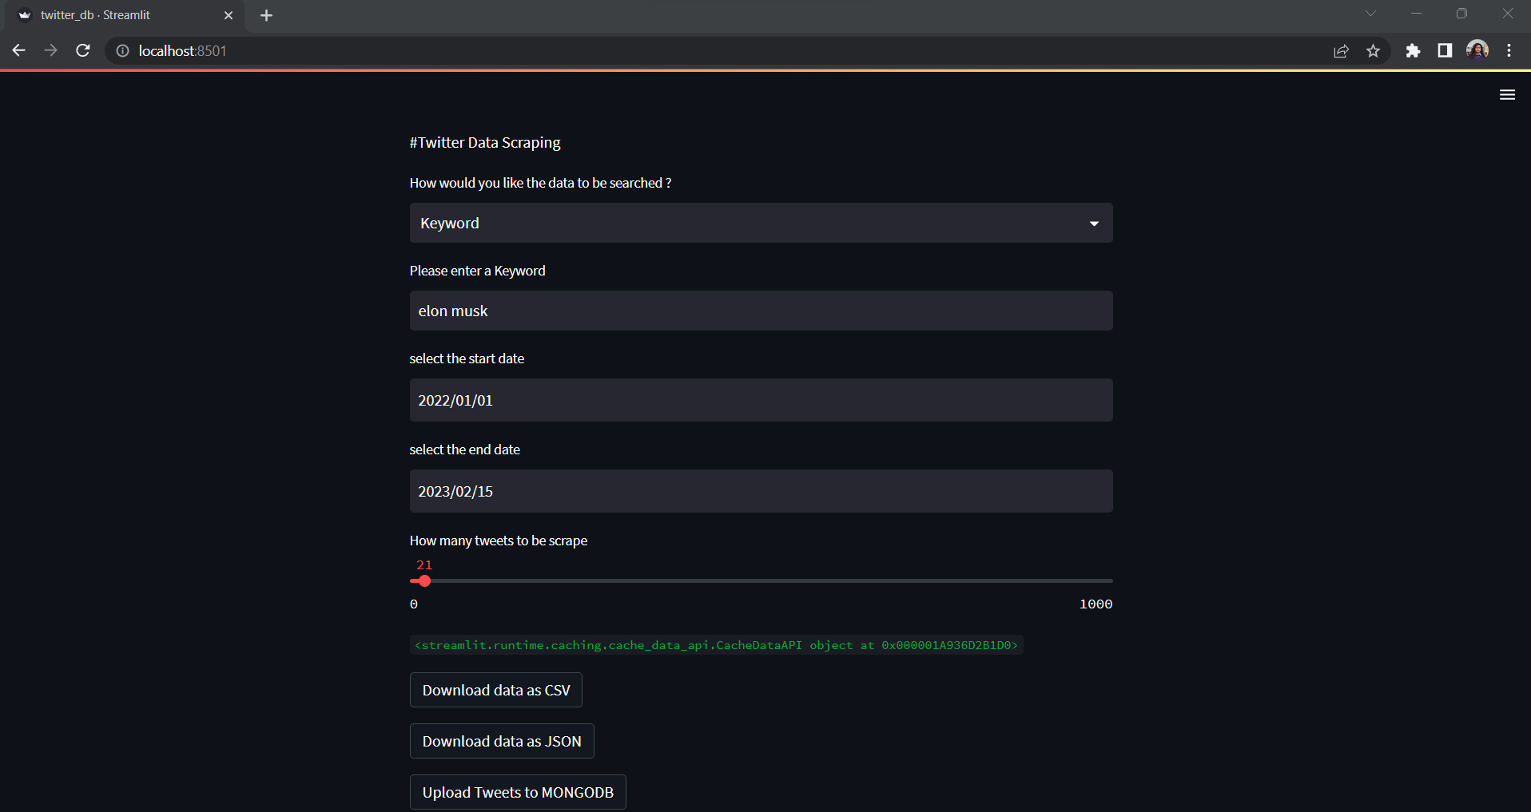

**MY MONGODB COMPASS UPLOADING MY TWEETS**:

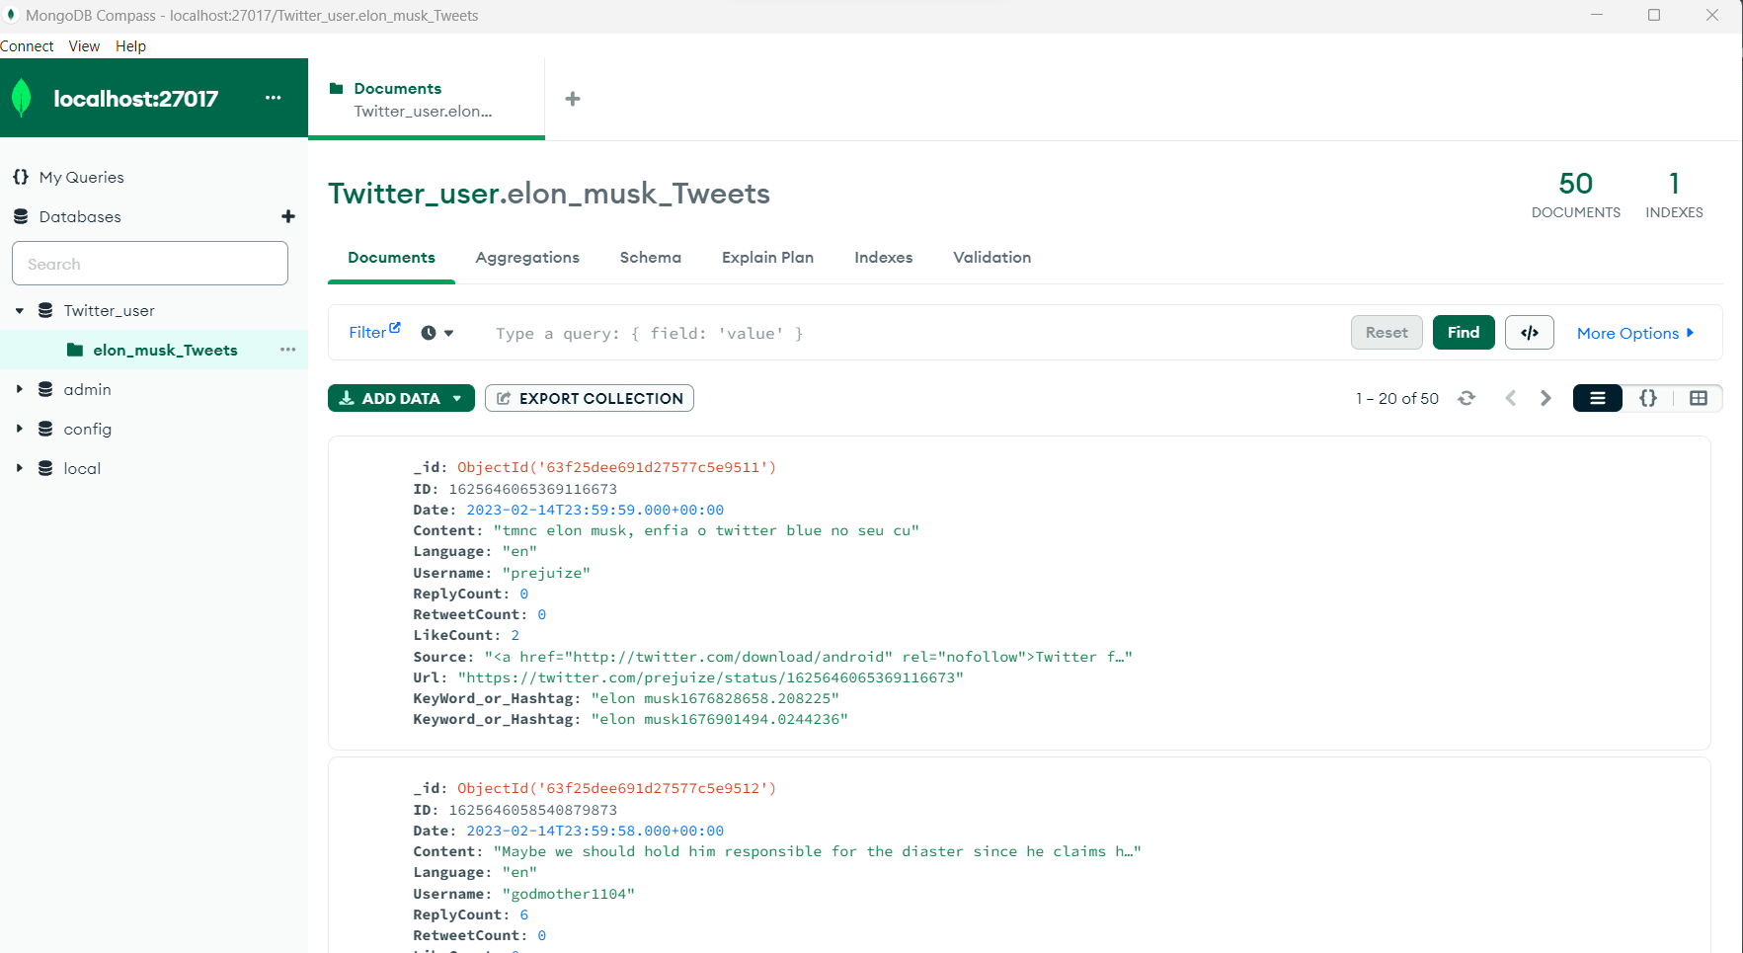

**LINK TO VIEW IN YOUR BROWSER:**

Local URL: <http://localhost:8501>

Network URL: http://192.168.0.102:8501